THE PAPER TIGER:
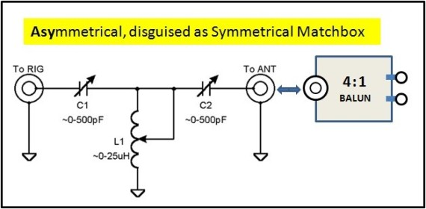

THIS IS NOT A SYMMETRICAL MATCHBOX.

And when running high power you will probably have problems with RF in the shack, especially if the matchbox has a 4:1 balun on the antenna side. The balun does not properly function as a balun when the SWR is too high. As a result you will have common mode current in the matchbox and in the shack.

You may notice this by:
- Equipment going into "fault"
- Hot mic or hot key, causing RF burns
- TVI, BCI, etc.

So the next "GURU" said "Do it this way:"

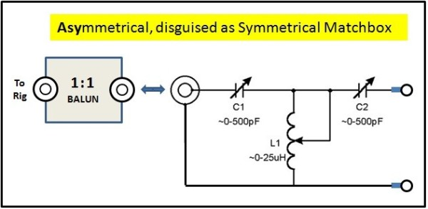
OK, this looks better:
- The enclosure of the Matchbox is now floating above ground; nothing is grounded inside the matchbox.
- The Balun is seeing its design impedance.
- Problem is, in practice it only works just a little bit better than the circuit above.
- In many attempts to perfect this, including trying several different types of baluns, I continued to have problems with RF in the shack when running high power.
- Yet when I replaced this with two different high power [true] symmetrical matchboxes, there were no more problems at all !
Bottom Line, this is better than the circuit above, but still just a work-around with hitches. If this is the best you can do, go ahead. But there are much better solutions.

MORE TECHNICAL DETAIL ON THIS TOPIC, BY W7EL, IS AVAILABLE ON THE FOLLOWING LINKS:
- http://eznec.com/misc/ibalbrf.txt﻿
- http://eznec.com/misc/ibalun.txt﻿
- http://www.eznec.com/Amateur/Articles/Baluns.pdf﻿

THIRD TIME IS THE CHARM: THIS ONE IS NOT BAD:

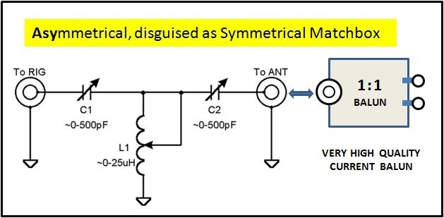

It's not bad, but it's not great. However with this circuit I was able to run one kilowatt without burning my fingers on the key, or my lips on the mic. A prerequisite for this is, you have to have a good matchbox which has no problem dealing with the high voltage due to the higher impedance when not using the 4:1 transformation in front of it. The variable capacitors should be rated about 6KV or more.

In my specific case, I used a Ten-Tec Model 238B, which is a very good L-Network.

A good T-Network will also work, if the capacitors are of the values shown here and have wide enough plate spacing.

NOTE: although my Ten-Tec Model 238B has a built-in 4:1 balun, I do not use it for the reasons explained above. Instead I use an external home-brew 1:1 current balun.

I have been using this for the past 10 years.
Recent reports from others confirm my experience.

For more explanation on why a 1:1 balun is better here than a 4:1 balun, see also:
- "Windom- und Stromsummen-Antennen" by Karl Hille, DL1VU, ISBN 3-910159-14-1, pages 106 and 107.
- Tuner Balun Ratios by Steve Hunt, G3TXQ

.

NEED YOU WORRY ? . . . and . . . HOW DO YOU KNOW ?

If you are running low power, up to 100w or so,
you can probably use any of these circuits shown on this page
without incurring any problem.
(Even the cheap work-arounds will work.)

If you have a little problem with RF in the shack, simply insert an RF Choke (beads over coax) in the transmission line between the matchbox and transceiver and your will probably be OK.

IF YOU ARE RUNNING HIGH POWER (500+w)

YES, YOU SHOULD BE CONCERNED.

HOW YOU WILL KNOW:
- You may have RF all over the shack.
- Transceivers or Amplifiers may be randomly going to FAULT condition.
- You may have interference with other equipment such as televisions or telephones.
- You will burn your lips on your mic and your fingers on your key.

IN THIS CASE YOU SHOULD FOLLOW THESE PRIORITIES:
- Get yourself a good, high power symmetrical matchbox, like a 1KW Annecke Symmetrical Koppler, Johnson Viking Matchbox, MFJ-976, Palstar BT-1500 or AT-2K-BT (BT=Balanced Tuner. It must be the model with "BT", not the previous model).
- If you only need one or two bands, consider home brewing a symmetrical tuner.
- If a symmetrical tuner is not an option at this time, then use the circuit showing a 1:1 current balun on the antenna side of the matchbox.
- Use either of the other two in a pinch, but don't be surprised if you get some shocking results. In this case it usually helps to insert an RF-Choke (beads over coax) between the matchbox and the amplifier.

